Database Project – Group 3

**Student Names:**

Bandana Pachabhaiya Magar (C0916126)

Kusum Lamichhane (C0917362)

Ranish Shrestha (C0916260)

Roshan Dhakal (C0916271)

Utsav Bajracharya (C0913555)

**Submitted date:** 08/11/2023

**Table of Contents**

**Part1 – Company Overview and Product** 1

Company Name 1

Company Overview/Description 1

Products 1

Product Attributes 2

**Part2 – Customer Sales Invoice** 3

Customer Sales Invoice 3

**Part3 – Entity Relationship Diagrams** 4

ER diagram 4

Relational Model 5

Relational Schema 7

Business Rules 8

**Table of Figures**

Figure 1 Product Attributes 2

Figure 2 ER diagram 4

# **Part1 – Company Overview and Product**

## Company Name

Oasis Hardware

## Company Overview/Description

Oasis Hardware Company specialize in the design, manufacturing, and distribution high-quality of different hardware products. It has consistently delivered different hardware solutions, and exceptional services and gained customer satisfaction. Our mission is to become the oasis of reliability in the hardware industry where people can find the perfect hardware solution that meets their needs, backed by strong support and services. Innovation is continuously run in Oasis Hardware Company where our research and development team constantly explore new technology, materials, and design to create more reliable solutions. We value customer feedback and continuously refine our products and services.

## Products

Oasis Hardware company provides a wide range of goods and equipment for building, house renovation, maintenance, and repair. Our goal is to offer top-notch hardware solutions to a variety of sectors and uses. The products we have are known for their quality and reliability. Here are some of the products offered by our company:

**Safety Gears department** – In this department, we store safety gear and equipment to prioritize worker safety. We have everything you need, such as safety helmets, gloves, dust masks, knee pads, work boots, ear protection, eye protection.

**Electrical Supply department** – Electrical tools, Extension cords, Switches, Circuit breakers, Wiring, Electrical outlets, Electrical connectors.

**Paint and painting supplies** – Paint color, Paint brushes, Rollers, Drop cloths, Painter tape and Paint trays.

**Home appliances** – Flooring (Tiles, Laminate, Hardwood), locks, knobs, handles, shelving, and organizers for cabinets.

## Product Attributes

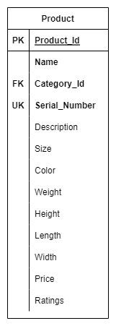

Figure Product Attributes

# **Part2 – Customer Sales Invoice**

## Customer Sales Invoice

**Customer ID**: 0001 **Order ID**: 00001

**Customer Name**: ABCD Company **Order Date**: 05/11/2023

**Customer Address**: 333 N Rivermede Rd **Associate ID**: 501

Toronto, ON L4K 3N7 **Associate Name**: Bob Smith

|  |  |  |  |  |  |  |
| --- | --- | --- | --- | --- | --- | --- |
|  |  |  |  |  |  |  |
| **Product ID** | **Model** | **Brand** | **Description** | **Qty** | **Unit Price** | **Extended Price** |
| S011 | 62-12345 | Lawn-Boy | Helmets | 2 | 595.00 | 1190.00 |
| E668 | 59-98765 | Black & Decker | Switches | 1 | 1449.00 | 1449.00 |
| P763 | 36-59278 | Craftsman | Paint and brush | 2 | 625.00 | 1250.00 |
| H004 | 45-78233 | Craftsman | Locks | 1 | 150.00 | 150.00 |
|  |  |  |  |  |  |  |
|  |  |  |  |  |  |  |
|  |  |  |  |  | **Sub-total** | 4039.00 |
|  |  |  |  |  | **Tax** | 525.07 |
|  |  |  |  | **Invoice Total** | | 4,564.07 |

**Customer ID**: 0002 **Order ID**: 00002

**Customer Name**: XYZ Company **Order Date**: 07/11/2023

**Customer Address**: 1120 Newkirk Rd **Associate ID**: 502

Toronto, ON L4K 3N7 **Associate Name**: Robin

|  |  |  |  |  |  |  |
| --- | --- | --- | --- | --- | --- | --- |
|  |  |  |  |  |  |  |
| **Product ID** | **Model** | **Brand** | **Description** | **Qty** | **Unit Price** | **Extended Price** |
| S011 | 62-12345 | Lawn-Boy | Knee Pads | 10 | 200.00 | 2000.00 |
| E668 | 59-98765 | Black & Decker | Switches | 1 | 1449.00 | 1449.00 |
| E700 | 36-59278 | Craftsman | Electric Connectors | 2 | 625.00 | 1250.00 |
| H004 | 45-78233 | Craftsman | Locks | 1 | 150.00 | 150.00 |
|  |  |  |  |  |  |  |
|  |  |  |  |  |  |  |
|  |  |  |  |  | **Sub-total** | 4849.00 |
|  |  |  |  |  | **Tax** | 630.37 |
|  |  |  |  | **Invoice Total** | | 5,479.37 |

Product id:

**Safety Gears department** – S

**Electrical Supply department** – E

**Paint and painting supplies** – P

**Home appliances** – H

# **Part3 – Entity Relationship Diagrams**

## ER diagram

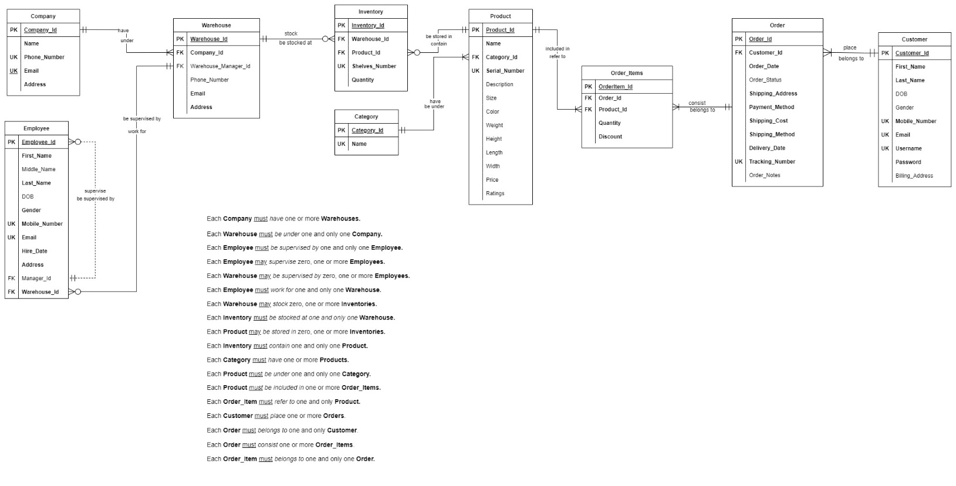

Figure ER diagram

*Figure SEQ Figure \* ARABIC 4 Customers ER Diagram*

## Relational Model

|  |  |  |  |  |
| --- | --- | --- | --- | --- |
| PRODUCTS | | | | |
| Key Type | Optionality | Column Name | Data Type | Length |
| PK | * | Product_Id | integer |  |
|  | * | Name | varchar | (20) |
| FK | * | Category_Id | integer |  |
| UK | * | Serial_number | character | (15) |
|  | 0 | Description | varchar | (100) |
|  | 0 | Size | integer |  |
|  | 0 | Color | varchar | (20) |
|  | 0 | Weight | decimal | (5,2) |
|  | 0 | Height | decimal | (3,2) |
|  | 0 | Length | decimal | (3,2) |
|  | 0 | Width | decimal | (3,2) |
|  | 0 | Price | decimal | (10,2) |
|  | 0 | Ratings | decimal | (2,1) |

|  |  |  |  |  |
| --- | --- | --- | --- | --- |
| WAREHOUSES | | | | |
| Key Type | Optionality | Column Name | Data Type | Length |
| PK | * | Warehouse_Id | integer |  |
| FK | * | Company_Id | integer |  |
| FK | 0 | Warehouse_Manager_Id | integer |  |
|  | 0 | Phone_Number | varchar | (10) |
| UK | * | Email | varchar | (50) |
|  | * | Address | varchar | (50) |

|  |  |  |  |  |
| --- | --- | --- | --- | --- |
| INVENTORY | | | | |
| Key Type | Optionality | Column Name | Data Type | Length |
| PK | * | Inventory_Id | integer |  |
| FK | * | Warehouse_Id | integer |  |
| FK | * | Product_Id | integer |  |
| UK | * | Shelves_Number | integer |  |
|  | * | Quantity | decimal | (10, 2) |

|  |  |  |  |  |
| --- | --- | --- | --- | --- |
| COMPANYS | | | | |
| Key Type | Optionality | Column Name | Data Type | Length |
| PK | * | Company_Id | integer |  |
| UK | * | Name | varchar | (50) |
| UK | * | Phone_Number | integer |  |
| UK | * | Email | varchar | (50) |
|  | * | Address | varchar | (20) |

|  |  |  |  |  |
| --- | --- | --- | --- | --- |
| EMPLOYEES | | | | |
| Key Type | Optionality | Column Name | Data Type | Length |
| PK | * | Employee_Id | integer |  |
|  | * | First_Name | varchar | (10) |
|  | 0 | Middle_Name | character | (1) |
|  | * | Last_Name | varchar | (10) |
|  | * | DOB | date |  |
|  | * | Gender | character | (1) |
| UK | * | Mobile_Number | varchar | (10) |
| UK | * | Email | varchar | (50) |
|  | * | Hire_Date | Date |  |
|  | * | Address | varchar | (50) |
| FK | 0 | Manager_Id | integer |  |
| FK | * | Warehouse_Id | integer |  |

|  |  |  |  |  |
| --- | --- | --- | --- | --- |
| CUSTOMERS | | | | |
| Key Type | Optionality | Column Name | Data Type | Length |
| PK | * | Customer_Id | integer |  |
|  | * | First_Name | varchar | (10) |
|  | * | Last_Name | varchar | (10) |
|  | 0 | DOB | date |  |
|  | 0 | Gender | character | (1) |
| UK | * | Mobile_Number | varchar | (10) |
| UK | * | Email | varchar | (50) |
| UK | * | Username | varchar | (10) |
|  | * | Password | varchar | (12) |
|  | 0 | Billing_Address | varchar | (50) |

|  |  |  |  |  |
| --- | --- | --- | --- | --- |
| ORDERS | | | | |
| Key Type | Optionality | Column Name | Data Type | Length |
| PK | * | Order_Id | integer |  |
| FK | * | Customer_Id | integer |  |
|  | * | Order_Date | date |  |
|  | 0 | Order_Status | varchar | (8) |
|  | * | Shipping_Address | varchar | (50) |
|  | * | Payment_Method | varchar | (8) |
|  | * | Shipping_Cost | decimal | (10, 2) |
|  | * | Delivery_Date | date |  |
|  | * | Shipping_Method | varchar | (8) |
| UK | * | Tracking_Number | varchar | (10) |
|  | 0 | Order_Notes | varchar | (50) |

|  |  |  |  |  |
| --- | --- | --- | --- | --- |
| ORDER_ITEMS | | | | |
| Key Type | Optionality | Column Name | Data Type | Length |
| PK | * | OrderItem_Id | integer |  |
| FK | * | Order_Id | integer |  |
| FK | * | Product_Id | integer |  |
|  | * | Quantity | decimal | (10, 2) |
|  | * | Discount | decimal | (10, 2) |

|  |  |  |  |  |
| --- | --- | --- | --- | --- |
| CATEGORY | | | | |
| Key Type | Optionality | Column Name | Data Type | Length |
| PK | * | Category_Id | integer |  |
| UK | * | Name | varchar | (50) |

## Relational Schema

PRODUCT(**Product_Id**, Name, *Category_Id*, Serial_Number, Description, Size, Color, Weight, Height, Length, Width, Price, Ratings)

FK *Category_Id* -> CATEGORY

WAREHOUSE(**Warehouse_Id** *Warehouese_Manager_Id*, Phone_Number, Email, *Postal_Code*, Address)

FK *Warehouese_Manager_Id* -> EMPLOYEE

FK *Postal_Code* -> POSTAL_ ADDRESS

INVENTORY(**Inventory_Id**, *Warehouse_Id*, *Product_Id*, *Department_Id*, Shelves_Number Quantity, DiscountAmount)

FK *Warehouse_Id* -> WAREHOUSE

FK *Product_Id* -> PRODUCT

FK *Department_Id* -> DEPARTMENT

DEPARTMENT(**Department_Id**, Name)

COMPANY(**Company_Id**, Name, Phone_Number, Email, *Postal_Code*, Address)

FK *Postal_Code* -> POSTAL_ ADDRESS

POSTAL_ADDRESS(**Postal_Id**, Postal_Code, City, State, Country)

EMPLOYEE(**Employee_Id**, First_Name, Middle_Name, Last_Name, DOB, Gender, Mobile_Number, Email, Hire_Date, *Postal_Code*, Address, *Manager_Id*, *Department_Id, Warehouse_Id*)

FK *Postal_Code* -> POSTAL_ ADDRESS

FK *Department_Id* -> DEPARTMENT

FK *Manager_Id* -> EMPLOYEE

FK *Warehouse_Id* -> WAREHOUSE

CUSTOMER(**Customer_Id**, First_Name, Last_Name, DOB, Gender, Mobile_Number, Email, Username, Password, Billing_Address)

ORDER(**Order_Id**, *Customer_Id*, Order_Date, Order_Status, Shipping_Address, Payment_Method, Shipping_Cost, Shipping_Method, Delivery_Date, Tracking_Number, Order_Notes)

FK *Customer_Id* -> CUSTOMER

ORDER_ITEMS(**OrderItem_Id**, *Order_Id*, *Product_Id,* Quantity, Discount)

FK *Order_Id* -> ORDER

FK *Product_Id* -> PRODUCT

CATEGORY(**Category_Id**, Name)

## Business Rules

Business rules for Oasis Hardware Company can help establish guidelines and standards for various aspects of your business operations. Here are some business rules of Oasis Hardware Company:

* A company has different types of products with different attributes.
* Company can have one or many warehouses.
* Products are kept in a warehouse for sale. Some products might not be available for sale.
* The company has a few employees. Each employee, except the CEO, is supervised by one manager.
* All managers are employees, but all employees are not managers.
* Each manager may supervise many employees.
* A manager may not have any employees reporting to him/her.
* Products are categorized into different categories.
* Some departments might only be categorized in the warehouse to store or display products.
* Each employee should work for at least one department.
* Customer should make one or more orders.
* Customer can make the same Orders once or many times.
* Customer can place an order for the same product or a different one.
* Quantity for an order should be one at least.
* Each employee should work for one warehouse. There should be a manager at warehouse.
* Each warehouse may have one or many employees to work for.